**M S RAMAIAH INSTITUTE OF TECHNOLOGY**

**(Autonomous Institute Affiliated to VTU)**

**Department of Information Science and Engineering**



Jan 2020 - May 2020

Topic:

**Educational Module**

*Submitted in fulfillment of the CIE for the subject*

**Java & J2EE**

**IS63**

**Signature of Faculty Project Team-**

Mr. Prashanth Kambli Tarun R - 1MS17IS123

Sumukh M Lohit - 1MS17IS120

1

**Table of Contents**

|  |  |  |
| --- | --- | --- |
| **Sl.No** | **Topic** | **Page No.** |
| 1 | Abstract | 3 |
| 2 | Introduction | 4 |
| 3 | Workflow Diagram | 5 |
| 4 | Outputs | 7 |
| 5 | Conclusion | 11 |
| 6 | Screenshots of Evaluation | 12 |
| 7 | References | 14 |

# 2

# **Abstract**

The student webapp project is done using servlets and jsp.

­­­The webapp basically consists of a login form for students and teachers. This is implemented by using MVC design pattern.

There is a separate login & signup for teachers and students. There is also an option to change the password. Then after logging in; the notes feature is present where the student or teacher can upload notes, download notes and merge notes

The module implemented is that pdf’s can be uploaded to the database which can be accessed by all students so that notes or documents can be shared with everyone. Also different pdfs can be merged.

The pdf splitting feature is made using java programming language with a Swing interface.

3

**Introduction**

# This project is designed to cater for students and teachers. It has a separate login id for teachers and students. The login page is created using Servlets and Jsp. The design pattern used for creating it is MVC.

The feature which is implemented is where students can scan and upload their notes in the form of pdf and this database is available for everyone so that they can retrieve any notes which are uploaded by any student or teacher.

As students would like to share notes among their friends, there is a need for a common place where all the shared notes would be available and which could also be merged with other pdfs.

Thus this platform would aid in sharing notes with classmates.

The pdf splitting feature is displayed using a swing interface, where the user selects a pdf which he wants to split, each page of that pdf will be taken and a new pdf will be created.

4

**Workflow Diagram**

**Signup & Login page**

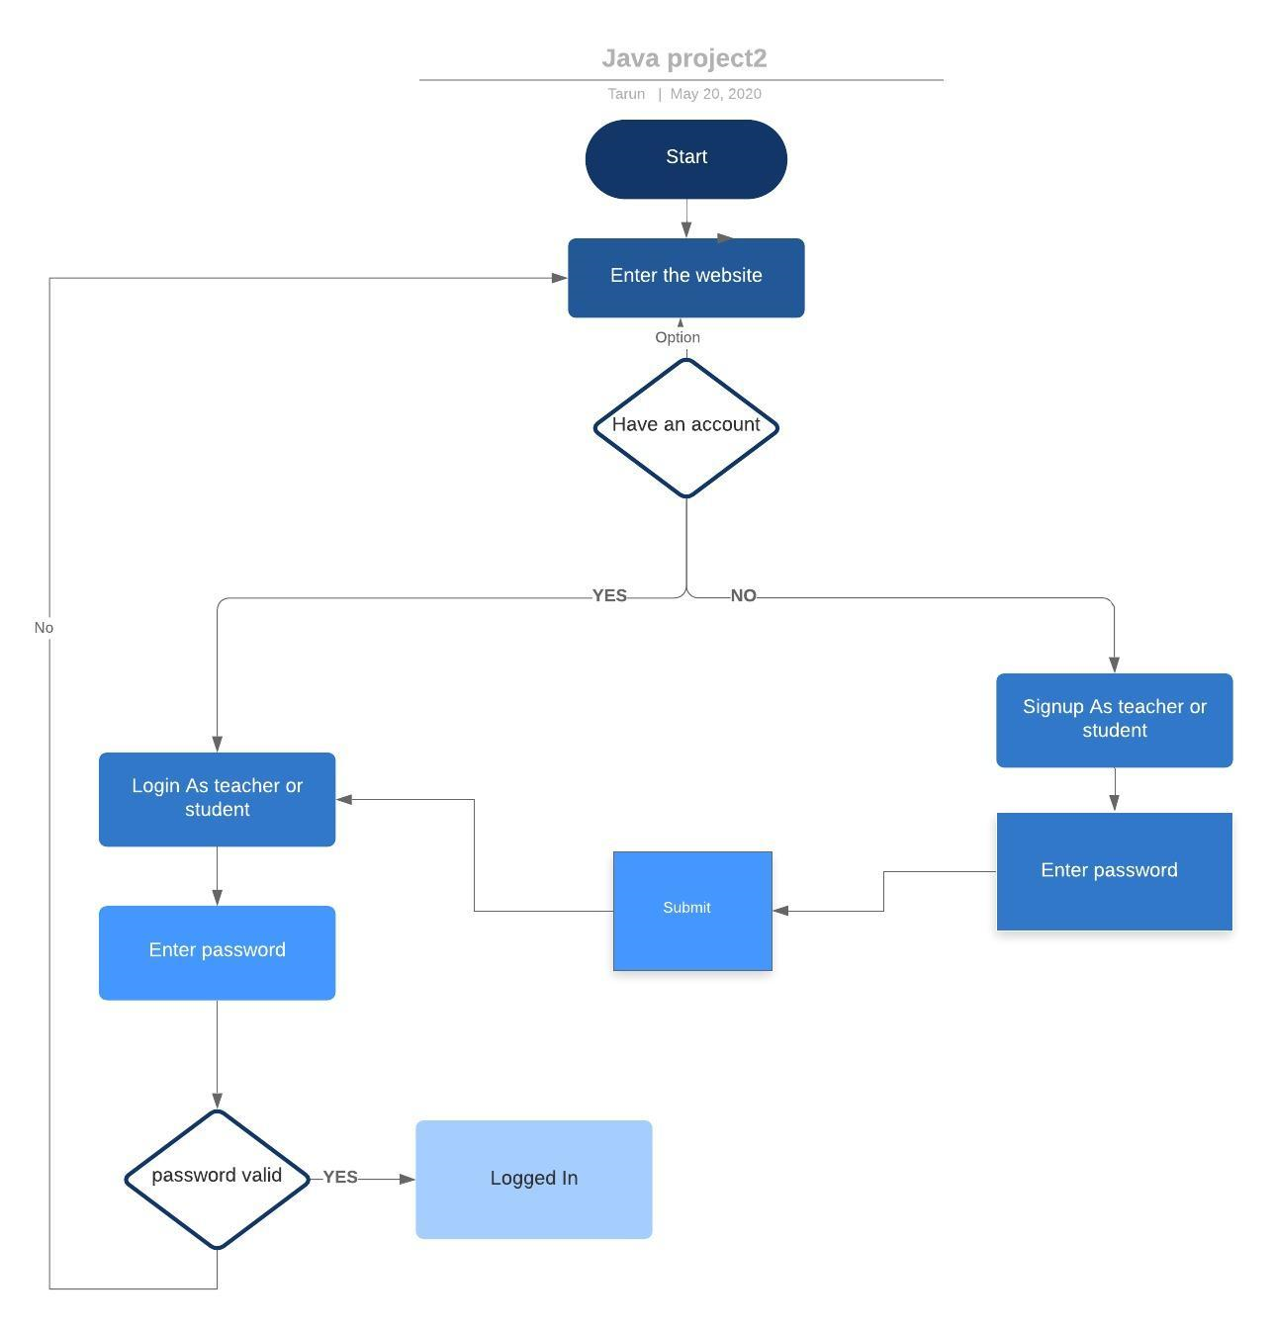

5

**Notes Upload & Download**

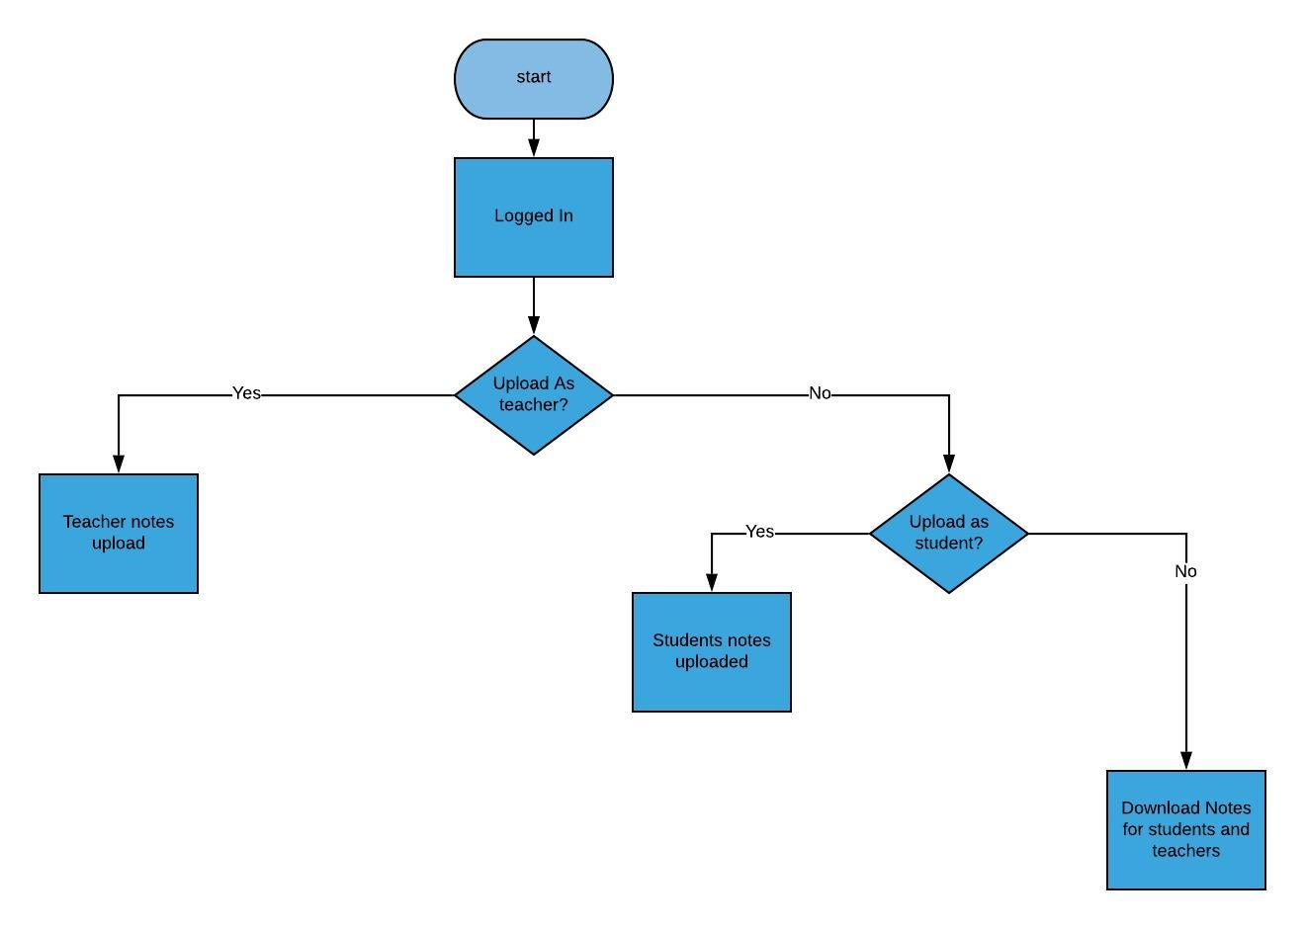

6

# 

# **Outputs Homepage**

# 

7

**Login page**

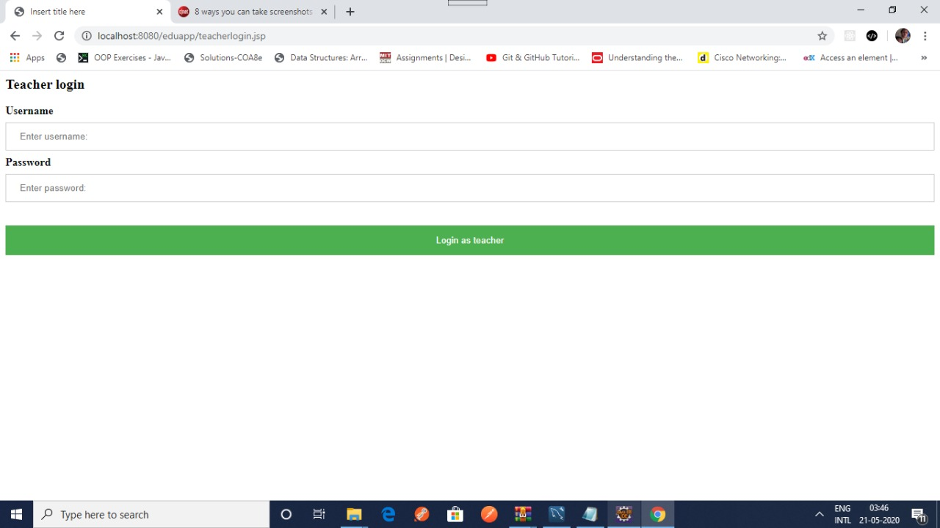

**Notes Feature Page**

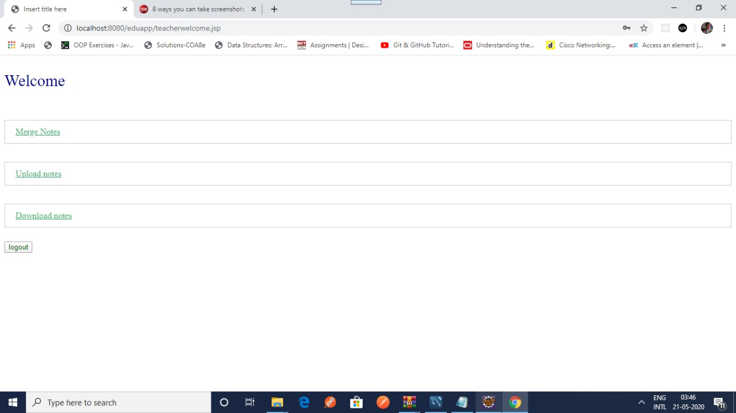

8

**Upload file page**

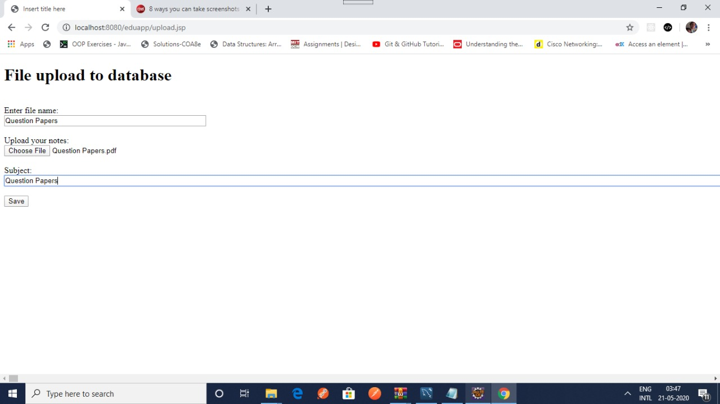

# **Notes Database**

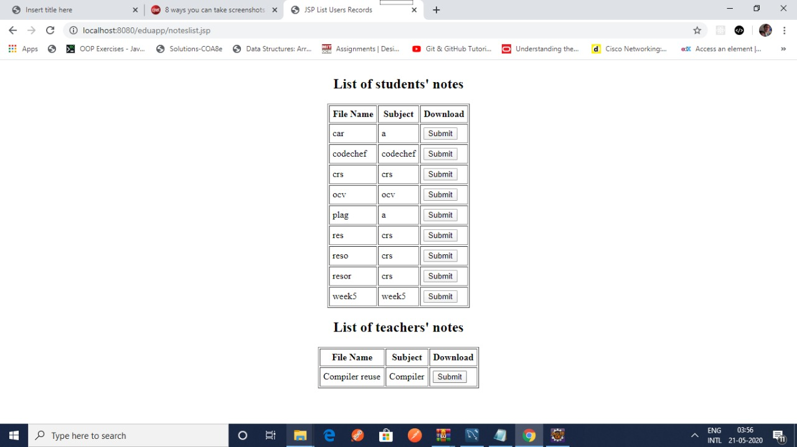

9

**PDF Splitting**

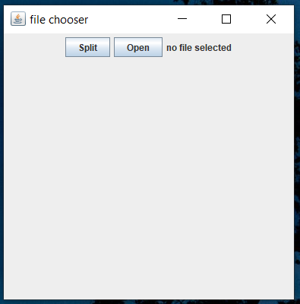

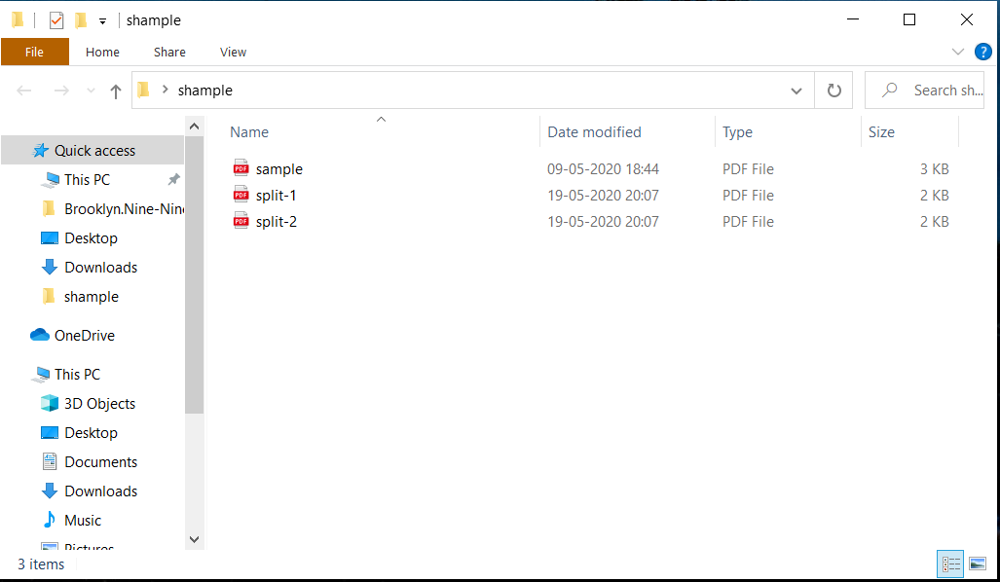

10

# **Conclusion**

# In conclusion, this web-app helps both students and teachers.

# They can upload their notes and also get notes from others.

# The merging feature is also helpful when a student wants only 1 document of all the notes present.

The pdf splitting is Used to separate a PDF into multiple documents by simply specifying the number of pages.

# 

11

# 

# **Screenshots of Evaluation:**

# **C:\Users\Tarun\Pictures\Screenshots\Screenshot (20).png**

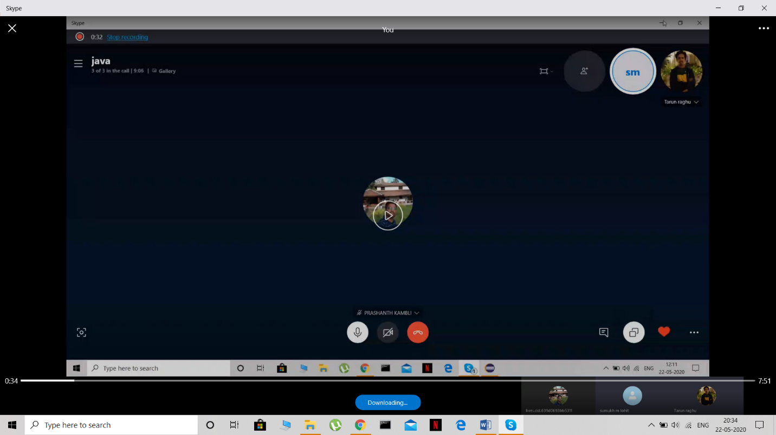

# **C:\Users\Tarun\Pictures\Screenshots\Screenshot (22).png**

# 13

# **References**

1. <https://www.mysqltutorial.org/mysql-jdbc-blob/>
2. <https://www.tutorialspoint.com/javaexamples/split_pdf_into_many.htm>

14